
KellPro Treasurers System
KellPro Treasurers System
© 2012... KellPro, Inc.
All rights reserved. Nothing in this document may be reproduced in any form by any means without the
permission of KellPro.
While every precaution has been taken in the preparation and production of this document, KellPro does not
assume responsibility for errors, omissions, or for damages resulting from the use of this document or from the
use of the software program referred to in this document. Use of this document constitutes agreement by the
user that KellPro cannot be held liable for any loss of profit or any other commercial damage caused or alleged to
have been caused directly or indirectly by the use of this document or by the use of the software program referred
to in this document.
Released May 2012 Duncan, Oklahoma, USA
Contents
5
Table of Contents
Foreword
0
Part I Welcome to the KellPro Treasurers System 6
6
Part II Accessing the Treasurers System
7
Part III KTS Bookkeeping
1 Daily Report
................................................................................................................................... 7
2 Deposits
................................................................................................................................... 7
3 Fiscal Calendar
................................................................................................................................... 7
4 G/L Accounts
................................................................................................................................... 7
5 Journal Entries
................................................................................................................................... 8
6 Misc Receipts
................................................................................................................................... 8
7 People
................................................................................................................................... 8
8
Part IV KTS Tax Module
Part V Using the System Screens - KEY Basics 8
1 Basic Functions - Overview
................................................................................................................................... 8
2 Date Fields
................................................................................................................................... 10
3 Fields with Special Behavior
................................................................................................................................... 11
4 Working With Grids
................................................................................................................................... 11
0
5
6
KellPro Treasurers System

1 Welcome to the KellPro Treasurers System
The KellPro Treasurers System (or KTS) provides a simple, comprehensive approach to
bookkeeping for County Treasurers. The primary responsibility of the County Treasurer is to
administer county monies. KTS assists the Treasurer as they receive and distribute all
county monies. KTS maintains an accurate accounting of all county monies received and
distributed. KTS assists with apportioning taxes to various accounts and to local public
entities such as schools and cities, keeps records of all payments and expenditures made by
the county and provides reports and financial statements.
Is this accurate???

Many Treasurers use KTS for tax accounting as well as bookkeeping by using the KTS Tax
Module. The Tax Module provides seamless integration of tax accounting and the
bookkeeping functions within KTS.
Add something about tax features

KTS provides the following:
- Tax Collections and Reporting
- Cash Register Program
- Appropriation and Warrant System
- Official Depository
- Daily and General Ledger
- Monthly Apportionment
- Monthly Report to the SA&I
- Miscellaneous Receipts
- Mortgage Tax and Trust Receipts
- Mobile Home Decal Program
- Check Writing and Investment Tracking Program
Which is in the bookkeeping side and which is in the tax module? Do we provide
additional functions?

KTS is a Windows based program that maintains full security of all county information.
Add something about security, backup of data, SQL, etc.

KTS is designed to be a bookkeeping and tax system that is easy to use while imposing
minimal restrictions on the user. If you have any questions about KTS, please contact a
KellPro representative at 888.535.5776 or please send us a question to sales@kellpro.com.

2 Accessing the Treasurers System
The KellPro Treasurers System is accessed by entering the Username and Password
provided by KellPro. Upon entering the correct credentials, the Main menu will appear as
shown:
show an image of the main menu here

Additional information on accessing KTS and logging out of KTS may be found here.

If there is a problem accessing KTS, please contact a KellPro representative at 888.535.5776.

3 KTS Bookkeeping
The KTS Bookkeeping menu provides the following menu items:

Daily Report
we know there are monthly, quarterly, etc reports. We'll have to
discuss

Deposits

Fiscal Calendar

G/L Accounts

Journal Entries

Misc Receipts

People we need a something more descriptive :-)
Each of these menu items will be described in this section.
We will correct the above as we get the system further developed.

3.1 Daily Report
Enter topic text here.

3.2 Deposits
Enter topic text here.

3.3 Fiscal Calendar
Enter topic text here.

3.4 G/L Accounts
Enter topic text here.

3.5 Journal Entries
Enter topic text here.

3.6 Misc Receipts
Enter topic text here.

3.7 People
Enter topic text here.

4 KTS Tax Module
The KTS Tax Module menu provides the following menu items:
Daily Report
Deposits
Fiscal Calendar
G/L Accounts
Journal Entries
Misc Receipts
People

Each of these menu items will be described in this section.
We will correct the above as we get the system further developed.

5 Using the System Screens - KEY Basics

5.1 Basic Functions - Overview
need to verify that this information is valid for KTS
Every KellPro Key System has a few basic functions that users need to be aware of. This
chapter tells about a few of these functions.















Login
Each user should have a unique username and password for the KellPro System. Each
time a person enters the system, they will have to supply their username and password.
The login will determine the security access rights, the area the user starts in, and many
other user-specific settings. When inside the Key System, the first button at the top of the
screen (the one that looks like a key) will be the Login button. When the user is done
using the computer, they should click this button to log their user out. This will allow the
next user to log in using their own username and password.

Insert, Delete, Change, and Close
These are the three most common buttons in the Key System. They will be on almost
every list of records.

Insert:
This will add a record to the list of records that is open. Pressing the Insert key
on the keyboard or pressing Alt+I will do the same thing as clicking this button.

Delete:
Delete will delete the record currently highlighted. Normally, the program will
pop up a confirm message, verifying that the user does want to delete the record.
Pressing the Delete key or Alt+D will do the same thing as clicking this button.

Change:
Change will open the record currently highlighted, allowing the record to be
edited or changed. Pressing Alt+E will also open the record for modification. When a
browse is opened, the Change button is normally available by pressing the Enter key on
the keyboard.

Close:
Close the list currently open.

OK (Save) and Cancel
Nearly every record in the Key program will have an OK and Cancel button. OK will save
any changes made to the record and close it. Cancel will close the record without saving
any changes that were made since it was last saved. F12 will also save and close the
record, and ESC will cancel and close the record.
Note: Often there are processes that will save a record, such as running a report. If
changes are made to the record, then one of these processes occurs, then the user
cancels out of the record, changes made before the process was ran will be saved.

Exiting your Key program
The program may be exited by pressing the Exit button on the top right of the screen or by
pressing F12 when all other windows are closed. F12 will close the window that is
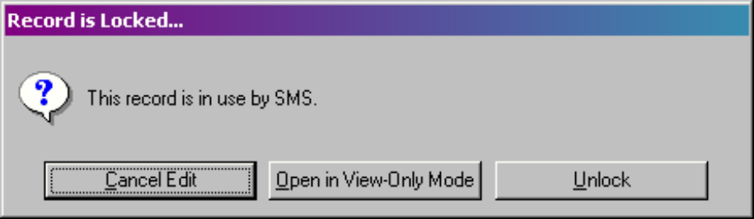
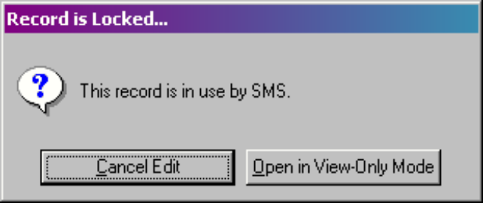

currently open, then return to the previous window. Pressing F12 until all windows are
closed, then pressing it again will bring up a message verifying that the user wants to exit
key. Pressing Yes on this message will close the program.

Unlocking Records
When a user opens a part of a system, the records that he or she is using are sometimes
locked. That means that no other user can open the records in use and make changes to
them. If a computer ever locks up while the first person is using a record, the record
becomes locked and no one can go in and use it. Users will get a message like this.
Key will give this message to anyone who tries to open the record. In this case, the user
with the initials of SMS was using the system and the computer locked up, and now when
the user tries to return to what he was doing, this is the message that pops up.
If another user with equal or lower security rights tries to open this record, the user will get
a different message with no option to unlock.

To correct this problem, someone with high security clearance or the person who locked
the record must unlock it. If a record is actually in use by a person and someone else
unlocks the record, the changes made to the record may be lost.

Refresh Lists
The F2 key will refresh any list of records when it is open.

Opening Menus or Screens
There are normally three ways to open a menu or a screen. Highlighting a record and
pressing Enter, clicking the List or Change button or double-clicking the record will open
the menu option or the record.

5.2 Date Fields
Date fields have unique behavior that allows faster data entry. The shortcuts are listed
below.
• pressing C on your keyboard will enter the [C]urrent date.




• pressing Y on your keyboard will enter [Y]esterday's date.

• pressing Ton your keyboard will enter [T]omorrow's date.

• A single digit, or two digits, will enter the current month and year with the day of the digits
you entered. If the current year and month is March, 2003, if 4 were entered onto a date
field, the date would be set to 3/4/2003.

• If the day and month where to be entered, for example 3-4, it would enter the date as the
day and month entered, with the current year.

• When entering dates, dashes, periods, slashes and backslashes may be used as
delimiters between the day, month and year. For example, 3-4-2003, 3.4.2003, 3/4/2003
and 3\4\2003 are all valid entries. Key will automatically format whatever is entered with
forward slashes after the focus leaves the field.

• If a date already exists on a field, pressing the + key will add one day to the date. The -
key will subtract one day.

• Double-clicking or pressing F3 on a date field will bring up a small calendar, where the
date may be selected.

• Entering a number in the day part of the date that is larger than the last day of the month
will automatically default the day to the last day of the month. If you were to enter
11/31/2003, it would automatically change it to 11/30/2003.

5.3 Fields with Special Behavior
need to verify that this information is valid for KTS
There are several types of behavior that fields in any key system may have.
A field may be required. This means that the field must be filled out before the record can
be saved and closed. A required field's label will be red. If a user attempts to save and
close a record without filling out a required field, the record will not close, and will place the
cursor in the required field.
A field can be a lookup. This means that there is a list of available entries. Lookup fields
will have a blue label. Some lookup fields are optional, allowing the user to type freeform
into the field, or press F3 to bring up a list of available entries. All lookup fields will bring
up a list of available entries if they are double-clicked or F3 is pressed while on the field.
A field may be a summary of detail fields. Summary fields will have a maroon label.
Double-clicking on a summary field will bring up a list of the records it is summing from.

5.4 Working With Grids
A grid is a list of detail records inside a main record. A grid allows the user to view, modify
and add detail records without ever leaving the main record. Grids are most commonly used
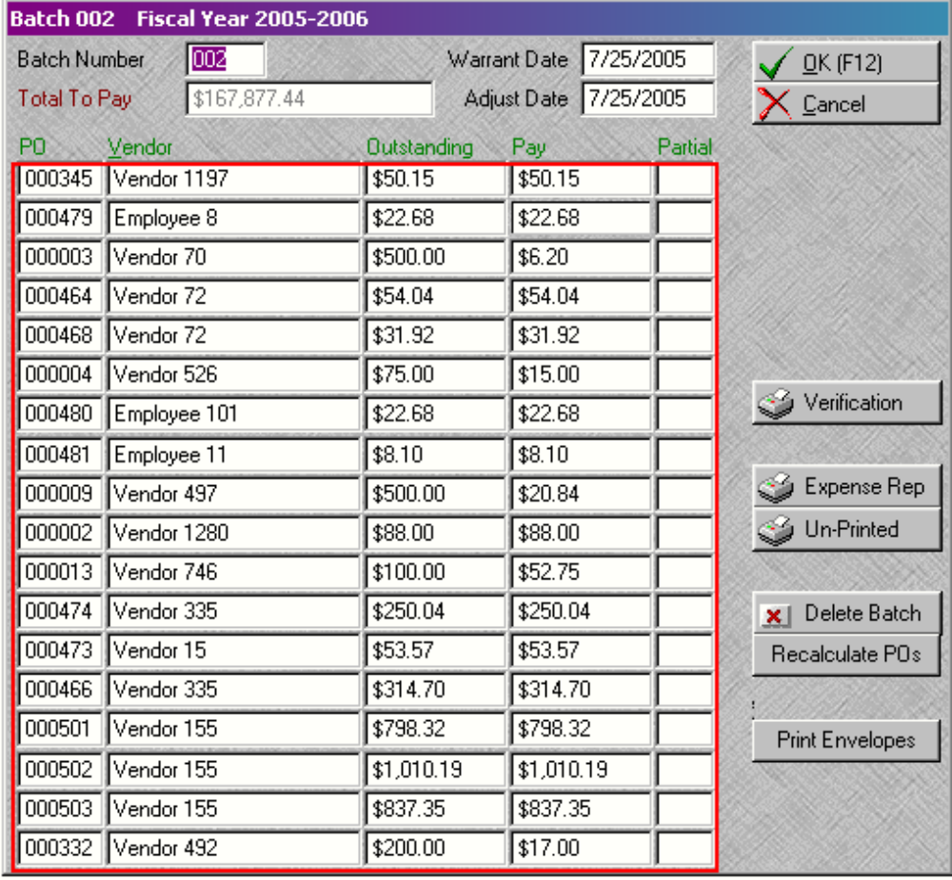
in KTS in the ????

When all grid details are full, if additional lines are needed, the page up and page down keys
will move between pages of details.
Sometimes the alignment on a grid will behave oddly. This usually happens on amount
fields. The "normal" odd behavior is a number aligning to the right when it is initially entered,
and then aligning to the left when the field is clicked on. This is normal behavior for a grid,
and should not cause alarm.

An example of a grid is shown inside the red box below.

Back Cover

